Assignments questions/answers

# 3

1.What are the primitive data types in C Languages?

* int, float, double, char, void.

2.What kind of statements can be written outside the function body?

* Declaration statement.
* example:- int a;

3.What is the size of float type variable?

* 4 byte.

4.What is the value of an uninitialized variable?

* 4 byte.

5.What is the difference between float and double?

* float variable size:- 4 bytes
* double size:- 8 bytes.

6.What is the full form of ASCII?

* American standard code for information interchange.

7.What is the difference between a keyword and a function?

* Keyword is the smallest unit of a program.
* Functions are build with the help of keywords.
* Keywords are pre-defined in compiler.
* Functions are not pre-defined.

8.Explore the use of type modifiers in C language.

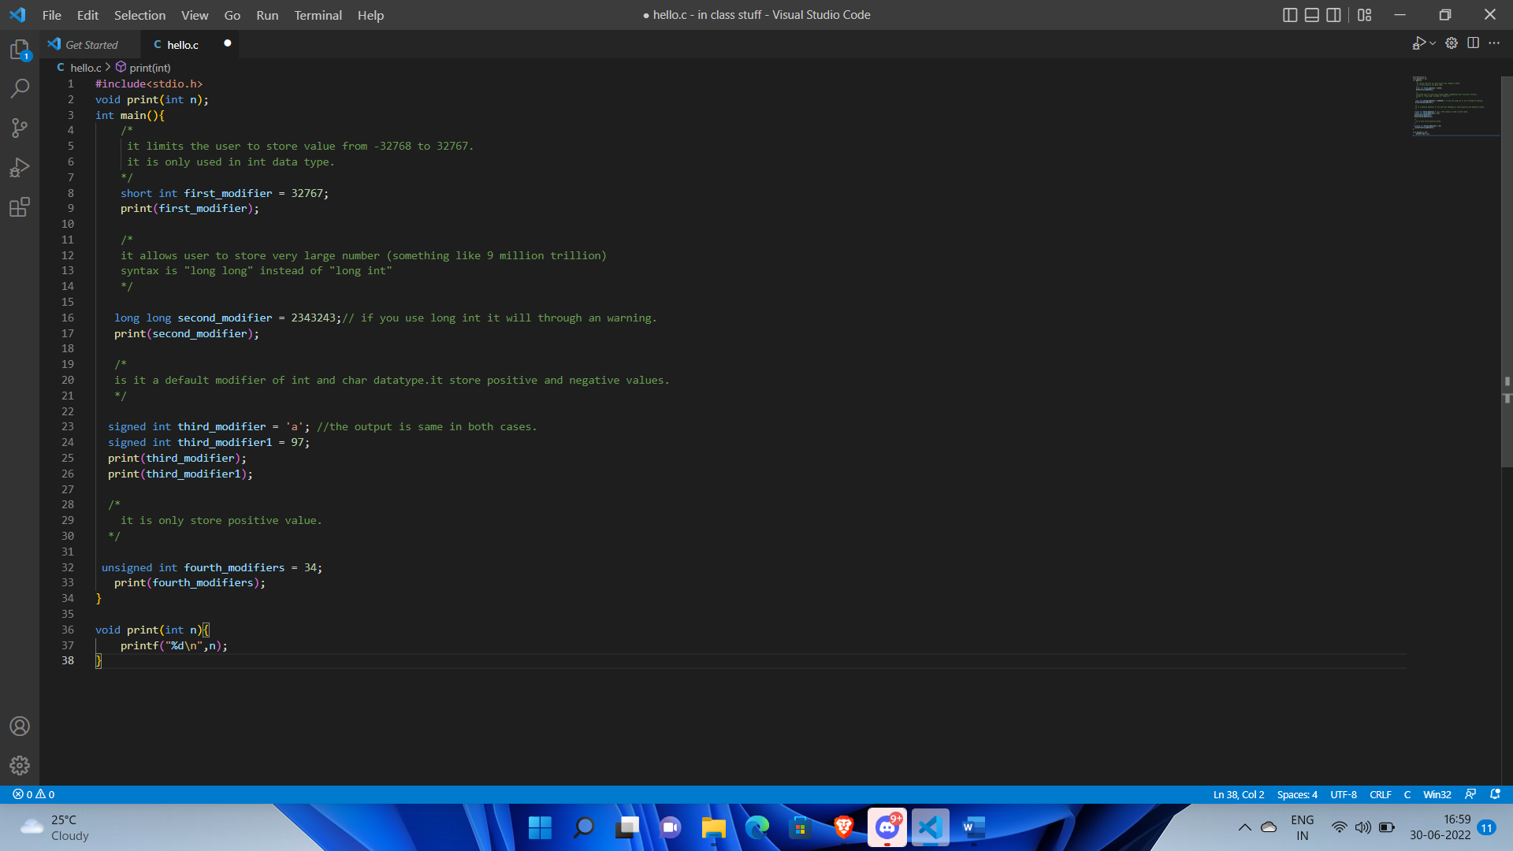

9.Can you assign a character constant in an int variable?

* Yes.

10.State the following statement as true or false-“Every block of code is a function”.

* True.